

Pupil Attendance Policy and Procedures

Tees Valley Education Trust

Version: | 1.4.3
Next review date: | August 2025
Director lead: | Emma Lowe
Operational Lead/Document Reviewer: | Louise Stogdale
Statutory (Y/N): | N
Published on website (Y/N): | Y
Type of document: | Procedure
Approved by: | Trust Board



TABLE OF CONTENTS
- STATEMENT OF INTENT 3
- EXPECTATIONS OF ATTENDANCE LEVELS 3
- RECORDING ATTENDANCE: LEGAL RESPONSIBILITIES 4
- PARENT/CARER RESPONSIBILITIES
  - Attendance reporting and absence 5
  - Medical appointments 5
  - Requests for Leave of Absence 5
  - Punctuality/Lateness……………………………………………………………………………………………………… 6
- ILLNESS: GUIDANCE FOR PARENTS/CARERS 6
- ATTENDANCE SUPPORT GRADUATED RESPONSES 7
  - Bespoke support …………………………………………………………………………………………………………… 8
  - Attendance Case Conferences and Attendance Action Plans………………………………………… 9
- PENALTY NOTICES FOR NON-ATTENDANCE AND OTHER LEGAL MEASURES 9
- LEAVERS 10
  - Transfer Request 10
  - Gypsy, Roma, Traveller, Showman and Showman families 10
APPENDIX 1: NHS RECOMMENDATIONS 11
APPENDIX 2: MIDDLESBROUGH LA CODE OF CONDUCT 15
APPENDIX 3: REDCAR & CLEVELAND LA CODE OF CONDUCT 21
APPENDIX 4: DfE ATTENDANCE CODES AND DESCRIPTORS……………………………………………………………. 37

STATEMENT OF INTENT
For a child to take full advantage of the educational opportunities offered, it is vital that they attend school, on time, every day the school is open unless the reason for the absence is unavoidable. The routines children develop around attendance and punctuality at school are the same as the expectations of any future employer in the world of work.
Tees Valley Education Trust (TVED) is committed to providing an education of the highest quality and endeavours to provide an environment where all young people feel valued and welcome. Parents/carers, pupils and the wider community all play a part in making each academy within TVED successful. Every child has the right to access the full education to which they are entitled.
As a trust we strive to achieve a goal of 100% attendance for all pupils. Every opportunity is taken to convey to the children and their families, the importance of regular and punctual attendance. Under Section 7 of the Education Act 1996, parents/carers are responsible for making sure that young people of compulsory school age receive full-time education. Parents have a legal responsibility to ensure their child’s regular attendance at the school where they are registered.
If a young person of compulsory school age who is registered at a school fails to attend regularly at the school, the parent is guilty of an offence under Section 444(1) of the Education Act 1996.
Parents / carers are primarily responsible for ensuring their school-registered child attends every day. Where attendance problems occur, appropriate and effective case management will take place. This will be bespoke to each case and may include a range of collaborative working between the pupil, parent/carer, academy, wider school community and Local Authority services.
Parents / carers are expected to follow the attendance policy within their child’s academy. Parents are encouraged to work in partnership with the academy and are expected to notify the academy of the reason for any of their child’s absences. Families are also encouraged to speak to academy staff with any areas of concern around attendance so that these can be addressed promptly.

EXPECTATIONS OF ATTENDANCE LEVELS
Following DfE best practice guidelines, TVED record pupil absence in number of days alongside end of year percentage attendance. TVED works to the following bands below.
GREEN Band 0 days (100%) to 4 days (97.9%) absence: Good level of attendance
YELLOW Band 5 days (97.4%) to 7 days (96.3%) absence: Good level of attendance
ORANGE Band 8 days (95.8%) to 10 days (94.7%) absence: Requires improvement
RED Band 11 days (94.2%) to 14 days (92.6%) absence: Cause for concern
BLACK Band 15 days (92.1%) to 19 days (90%) absence: Serious cause for concern
20 plus days (Less than 90%) absence: Persistent Absentee

The national target for mainstream attendance is 95%. At TVED, we aspire to support our mainstream children to achieve 96%. The national target for special/unit provision attendance is 89%. At TVED, we aspire to support our children who attend special/unit provision to achieve 90%.
Pupils are expected to:
  - Attend their academy regularly and punctually.
  - Pupils should be appropriately prepared for each day.
  - Pupils, in line with both attendance and safeguarding policy, should be encouraged to talk to their teacher / member of academy staff about any problems that prevent them from attending the academy.
Good attendance is important because:
  - Statistics show a direct link between under-achievement and absence below 96%
  - Regular attenders make better progress, both socially and academically and find academy routines, work and friendships easier to cope with
  - Regular attenders are more successful in transferring between primary school, secondary school, higher education, employment or training
Each individual Home/Academy attendance agreement contains further details of how academies manage attendance on a daily basis in relation to the specific local authority expectations (Middlesbrough or Redcar and Cleveland). They give clarity of what pupils and parents / carers are expected to do to ensure their child achieves good attendance.
If absence is frequent or continuous, except where a child is clearly unwell, and there is medical evidence to support this, staff will discuss with parents/carers the need and reasons for their child’s absence and will encourage them to keep absences to a minimum.

A note or explanation from a pupil’s home does not mean an absence becomes authorised. The decision whether or not to authorise an absence will always rest with the Head Teacher.

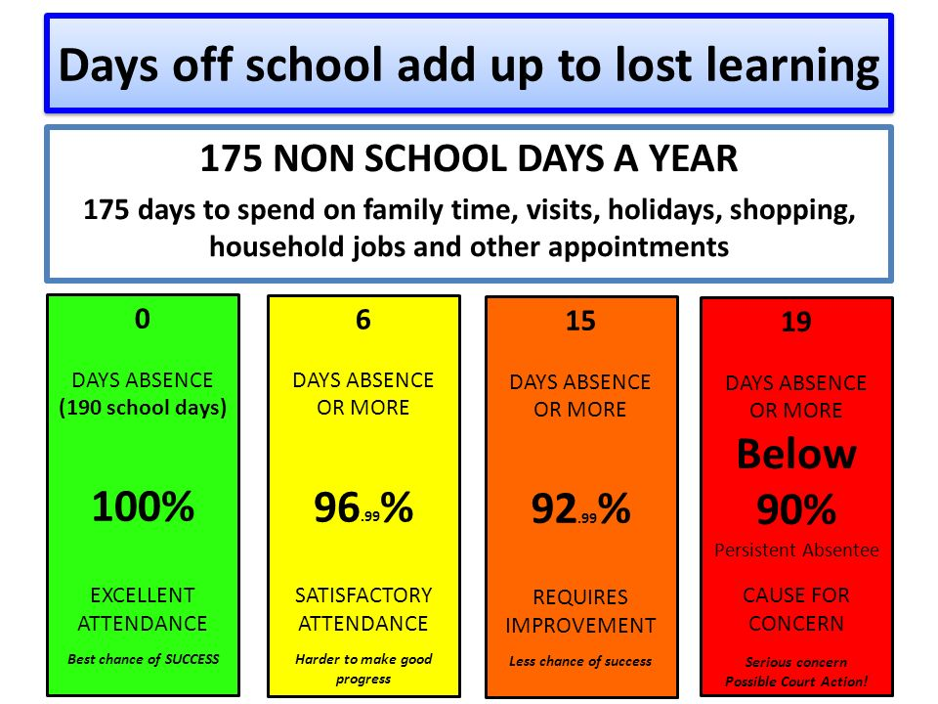
The impact absence has on attendance
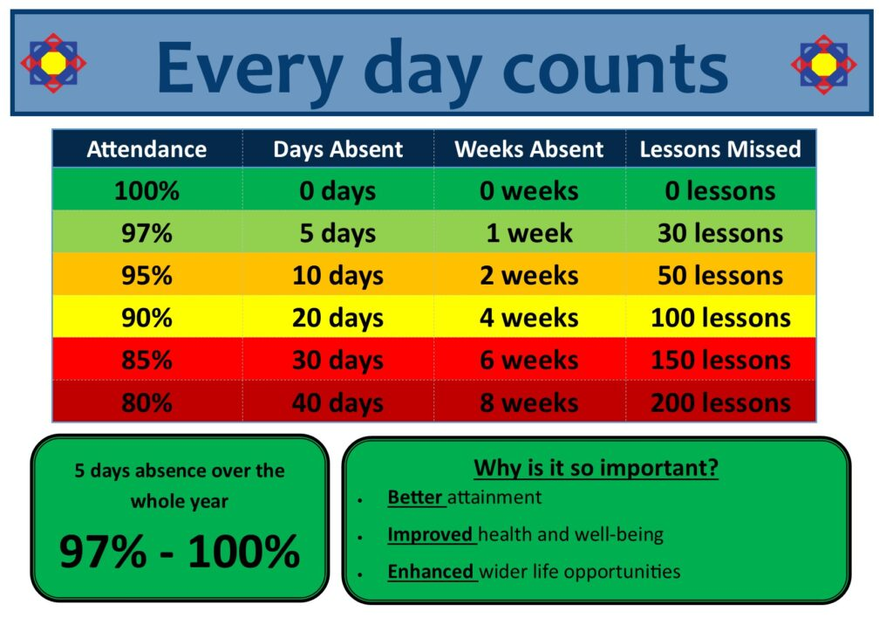

RECORDING ATTENDANCE: LEGAL RESPONSIBILITIES
From the start of the 2024-2025 academic year, it will be mandatory for all Schools in England to share their attendance with the DfE. This will be publicly available to anyone who wishes to view attendance data https://explore-education-statistics.service.gov.uk/find-statistics/pupil-attendance-in-schools
Young people are expected to attend school every day for the entire duration of the academic year unless there is an exceptional reason for their absence.
Schools must legally take an attendance register twice a day. The first mark is taken at morning registration and again at afternoon registration. There are two attendance sessions every day, AM and PM, therefore missing school for a whole day counts as two absences.
Any absences will be recorded with a specific code depending on the type of absence. Absences fall into two main categories:
Authorised Absence: is when the school has accepted the explanation offered as satisfactory justification for the absence, or has given approval in advance for such an absence. If no explanation is received, absences will not be authorised.
Unauthorised Absence: is when the school has not received a reason for absence, or has not approved a child’s leave of absence from school after a parent’s request.
Absence and attendance codes are held by individual academies in line with national expectation. These national codes enable schools to record and monitor attendance and absence in a consistent way which complies with regulations.
A school can, if needed, change an authorised absence to an unauthorised absence and vice versa if new information is presented. An example of this would be where a parent states a child is unwell but on return to school there is evidence they have been on holiday.
- PARENT/CARER RESPONSIBILITIES
Individual attendance agreements for a child’s respective academy can be located on their academy website under Attendance.
  - Attending and reporting absence

Bring your child to school every day on time.
Contact school by 9am every day that your child will be absent.

4.2 Medical Appointments

Make dentist/optician/doctors appointments, where possible, outside of school hours. If during school hours, after 2pm. If this is not possible, children should only be out of school for the minimum amount of time necessary for the appointment then return, should time allow. Taking a whole day off school for a dental or medical appointment is unacceptable.

Provide evidence for ALL medical appointments taking place during the school day before your child attends the appointment. This could be appointment text, card or letter. This is so the academy can authorise the absence. Failure to provide evidence will result in the absence being recorded as unauthorised.

4.3 Request for Leave of Absence
Complete a Leave of Absence form (available from website and school office) for all planned days of school such as holidays, funerals, performances, sporting events etc, at least two weeks before the first day of absence.

The Head Teacher is allowed to authorise an absence only for exceptional circumstances. There is no legal entitlement for time off in school time to go on holiday.

For holidays that meet or exceed the number of sessions threshold set down in Middlesbrough Council or Redcar & Cleveland Councils Code of Conduct, parents/carers are likely to be issued with a fixed penalty fine or face other legal action in accordance with the code.

Schools at both national level from the DfE and local level from Middlesbrough and R&C authorities have been directed to apply for penalty notices for all children of school age unless the leave of absence is evidenced as exceptional circumstances.

4.4 Punctuality/Lateness
Pupils are expected to be on time at the start of the morning and afternoon school sessions. If a child is late they can miss work and time with their class teacher getting vital information. Lateness can cause disruption to the lesson for others and can be embarrassing for the child, leading to possible further absence.
Parents / carers must ensure that pupils arrive on time in line with individual academy registration and daily timetable. Please see individual academy information for relevant expectations.
All lateness is recorded daily. This information will be required by the courts, should a prosecution for non- attendance or lateness be necessary.
If a child arrives after the close of registration with a genuine reason, this will be taken into consideration. Each case of lateness is treated on an individual basis.
If a child arrives after registration without a genuine reason or is consistently late, then a phone call home will be made by a member of the Pastoral Team.
For health and safety reasons it is important that the school knows who is in the building. Pupils arriving late should therefore report to the main school office. It is important that all pupils arriving late follow this procedure.
Parents/carers of young people who have patterns of lateness will be contacted by the Pastoral Team to discuss the importance of good timekeeping and how this might be achieved.

ILLNESS: GUIDANCE FOR PARENTS/CARERS
When a child is unwell, it can be hard deciding whether to keep them off school. The home / academy agreement encourages parents to contact school for advice should they be unsure.
Where pupils are kept off inappropriately for illness, the academy pastoral team will request the pupil be brought in, in order to minimise lost learning time.
Guidelines from www.nhs.uk are used by the Trust and may also help parents/carers.
Vomiting: If your child has vomited due to illness, they can return to school 48 hours after the last episode of vomiting. If your child has vomited for a non-illness related reason, eg, over-eating, over tired or gag reflex etc, they do not need to stay off school.

See Appendix 1 for NHS recommendations

ATTENDANCE SUPPORT GRADUATED RESPONSES
TVED holds the safeguarding of all pupils as the highest priority. A child not attending school is considered a safeguarding matter. Academies within the Trust retain the right to contact social care in line with safeguarding protocol at any point during the procedures below should there be concerns for a pupil’s/ family’s welfare.
At TVED we have two attendance graduated responses. The first is for compulsory school age children which includes details of the legal implications of absence. The second is for children in Nursery and Reception (up to the term after their fifth birthday when they will become compulsory school age) called the Pre-5 graduated response. We appreciate that pre-5 children, parents/carers and families can face the same challenges and barriers to attendance as school age children and as we want to support all to overcome these challenges and barriers regardless of the child’s age.
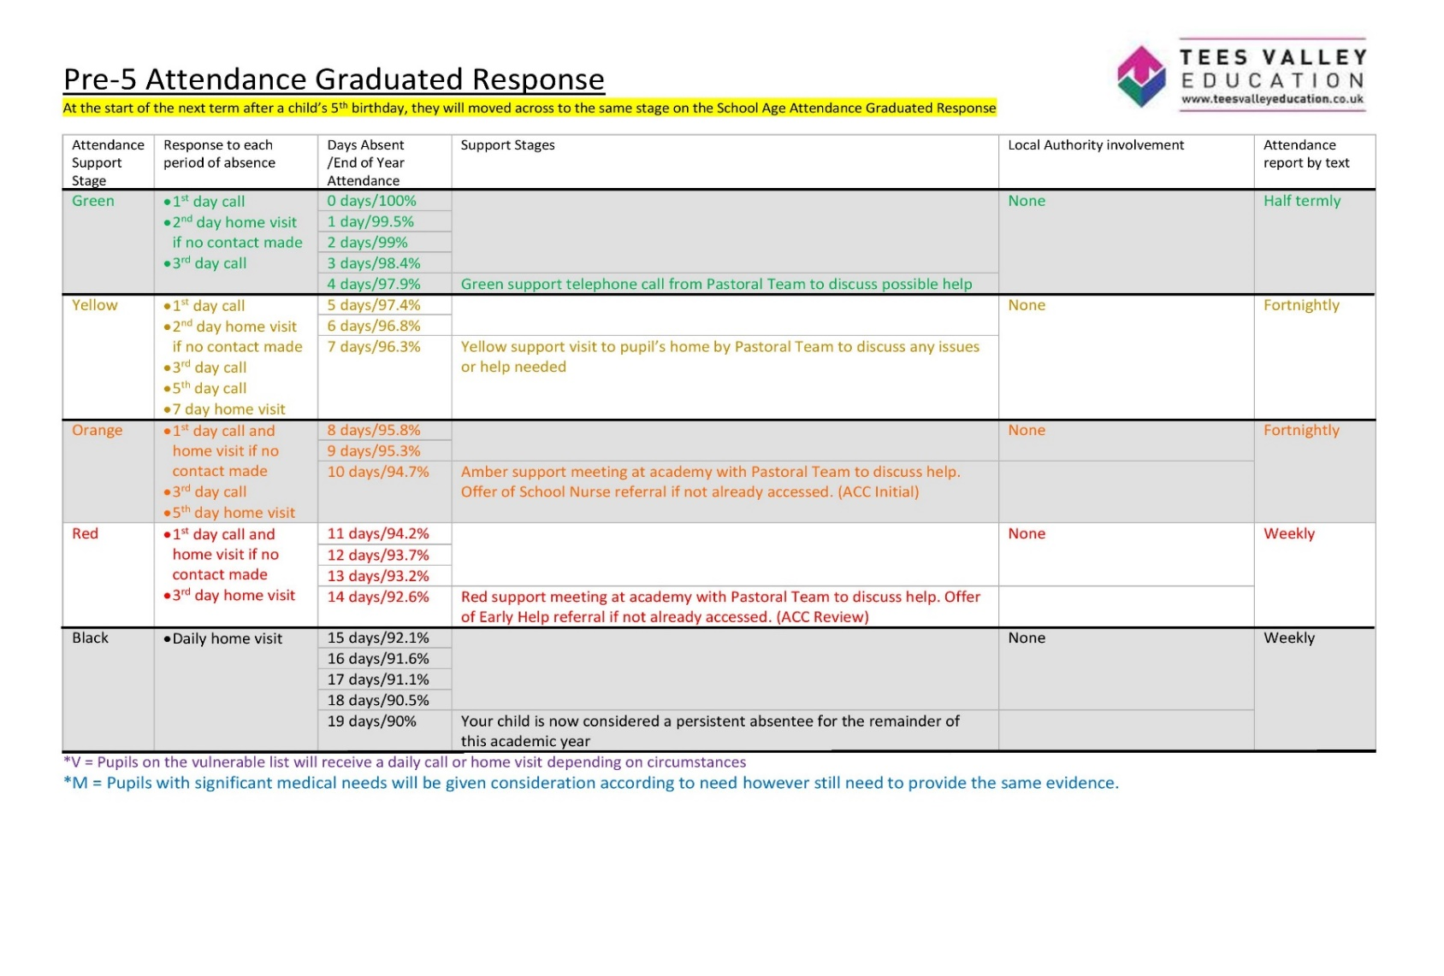
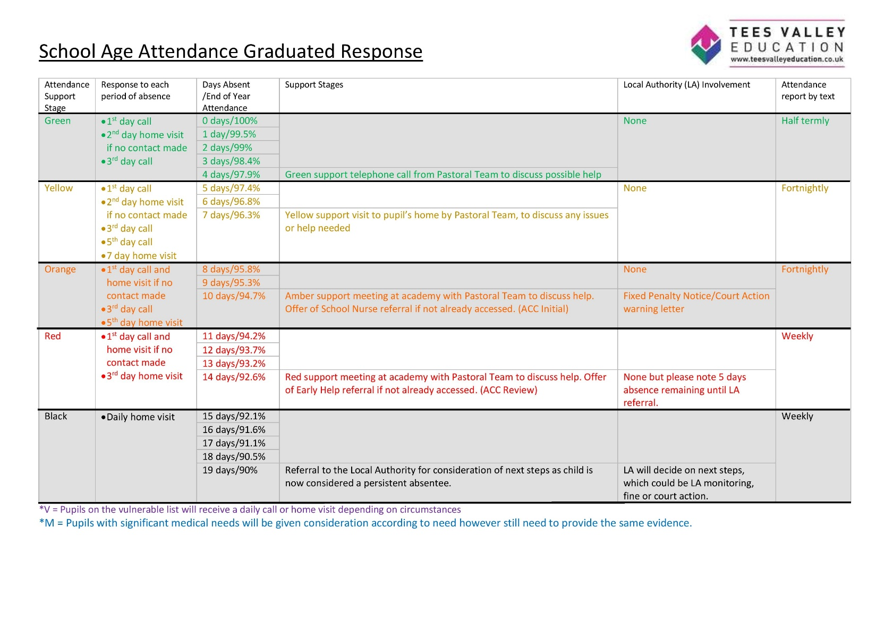

Bespoke Support:
In line with the attendance level table, bespoke support will be given to individual families regarding attendance issues for the first four to nine days of absence within an academic year using a combination of communication methods. This support will be tailored to meet the need of families and individual pupils, and always with a clear focus on improved pupil engagement. Once children reach ten days absence within an academic year, the relevant local authority guidelines will be followed, which will begin with invitation for parents/carers to attend an Attendance Case Conference meeting (ACC).

Attendance Case Conference (ACC) and Attendance Action Plan:
Where pupil attendance is below expectation, or an improvement in pupil attendance does not take place, parents / carers will be invited to attend an ACC within the academy. This is a meeting held with the academy welfare officer and a designated member of staff within each setting. This meeting will address the academy concerns surrounding attendance / punctuation, discuss support in place, and allow families to raise any concerns. Further plans and expectations of attendance will be agreed at this meeting. A formal agreement called an Attendance Action Plan will be drawn up between the Academy and parents/carers. Clear expectations of the parents/carers and pupil will be set out in the plan, with a date for review agreed at the end of the meeting. Fixed Penalty notices may also be issues at this time. Failure in improvement will result in involvement with the Local Authority, with possible fine and court action.

PENALTY NOTICES FOR NON-ATTENDANCE AND OTHER LEGAL MEASURES
Legal Measures for tackling persistent absence or lateness
TVED and Middlesbrough Local Authority and Redcar & Cleveland Local Authority will use the full range of legal measures to secure good attendance.
The following legal measures are for pupils of compulsory school age who are registered at a school: Parenting contracts set at Education Planning Meetings:
Parenting orders Penalty notices
Education Supervision Orders Prosecution
Where a child has unauthorised absence the school must enforce the Local Authorities Code of Conduct for issuing Penalty Notices or follow its guidance on other Legal Measures for Non-Attendance. The Code of Conduct is a statutory document that ensures that powers for legal sanctions are applied consistently and fairly across all schools and families within the local authority.

See Appendix 2. Middlesbrough LA Code of Conduct

See Appendix 3. Redcar & Cleveland LA Code of Conduct

The Penalty Notice is a fine that is issued to each parent/carer who is responsible for the child during the period of unauthorised absence for which the fine has been issued. Parents/carers will be warned of the likelihood of a Penalty Notice being issued for unauthorised absence via a letter in line with the academy Attendance Case Conference meetings or academy procedures. For each case of unauthorised absence, the respective Local Authority will decide whether a Penalty Notice, and the level of such notice, is issued to one or more parent/carers for each child.
Penalties can be used where the pupil’s absence has not been authorised by the school. Penalties may also be issued where parents allow their child to be present in a public place during school hours without reasonable justification during the first five days of a fixed period or permanent exclusion.

LEAVERS

Transfer Request
When a child is leaving any TVED academy, parents/carers are asked to submit a transfer request to the Head Teacher with all required information detailed. The transfer request will then be submitted to the Local Authority.
If pupils leave and we do not have the above information, then the child is considered to be a ‘Children Missing in Education’. The relevant safeguarding and absence procedures will be followed in line with protocol previously stated.

8.2 Gypsy, Roma, Traveller, Showman and Showman families
The absence of a child from a Traveller family that has left the area may be authorised if the absence is for work purposes only and it is believed that the family intends to return. To ensure the continuity of learning for Traveller children, dual registration is allowed. That means that a school cannot remove a Traveller child from the school roll while they are travelling. When the Traveller is away, the home school holds the place open and records the absence as authorised through the ‘T’ code. Distance learning packs for Traveller children are not an alternative to attendance at school.
This policy has been informed by the following legislation and national guidance DfE Working Together to improve school attendance (February 2024)
DfE Summary table of responsibilities for school attendance (February 2024)
DfE Keeping Children Safe in Education 2023

APPENDIX 1: NHS RECOMMENDATIONS – JUNE 2024

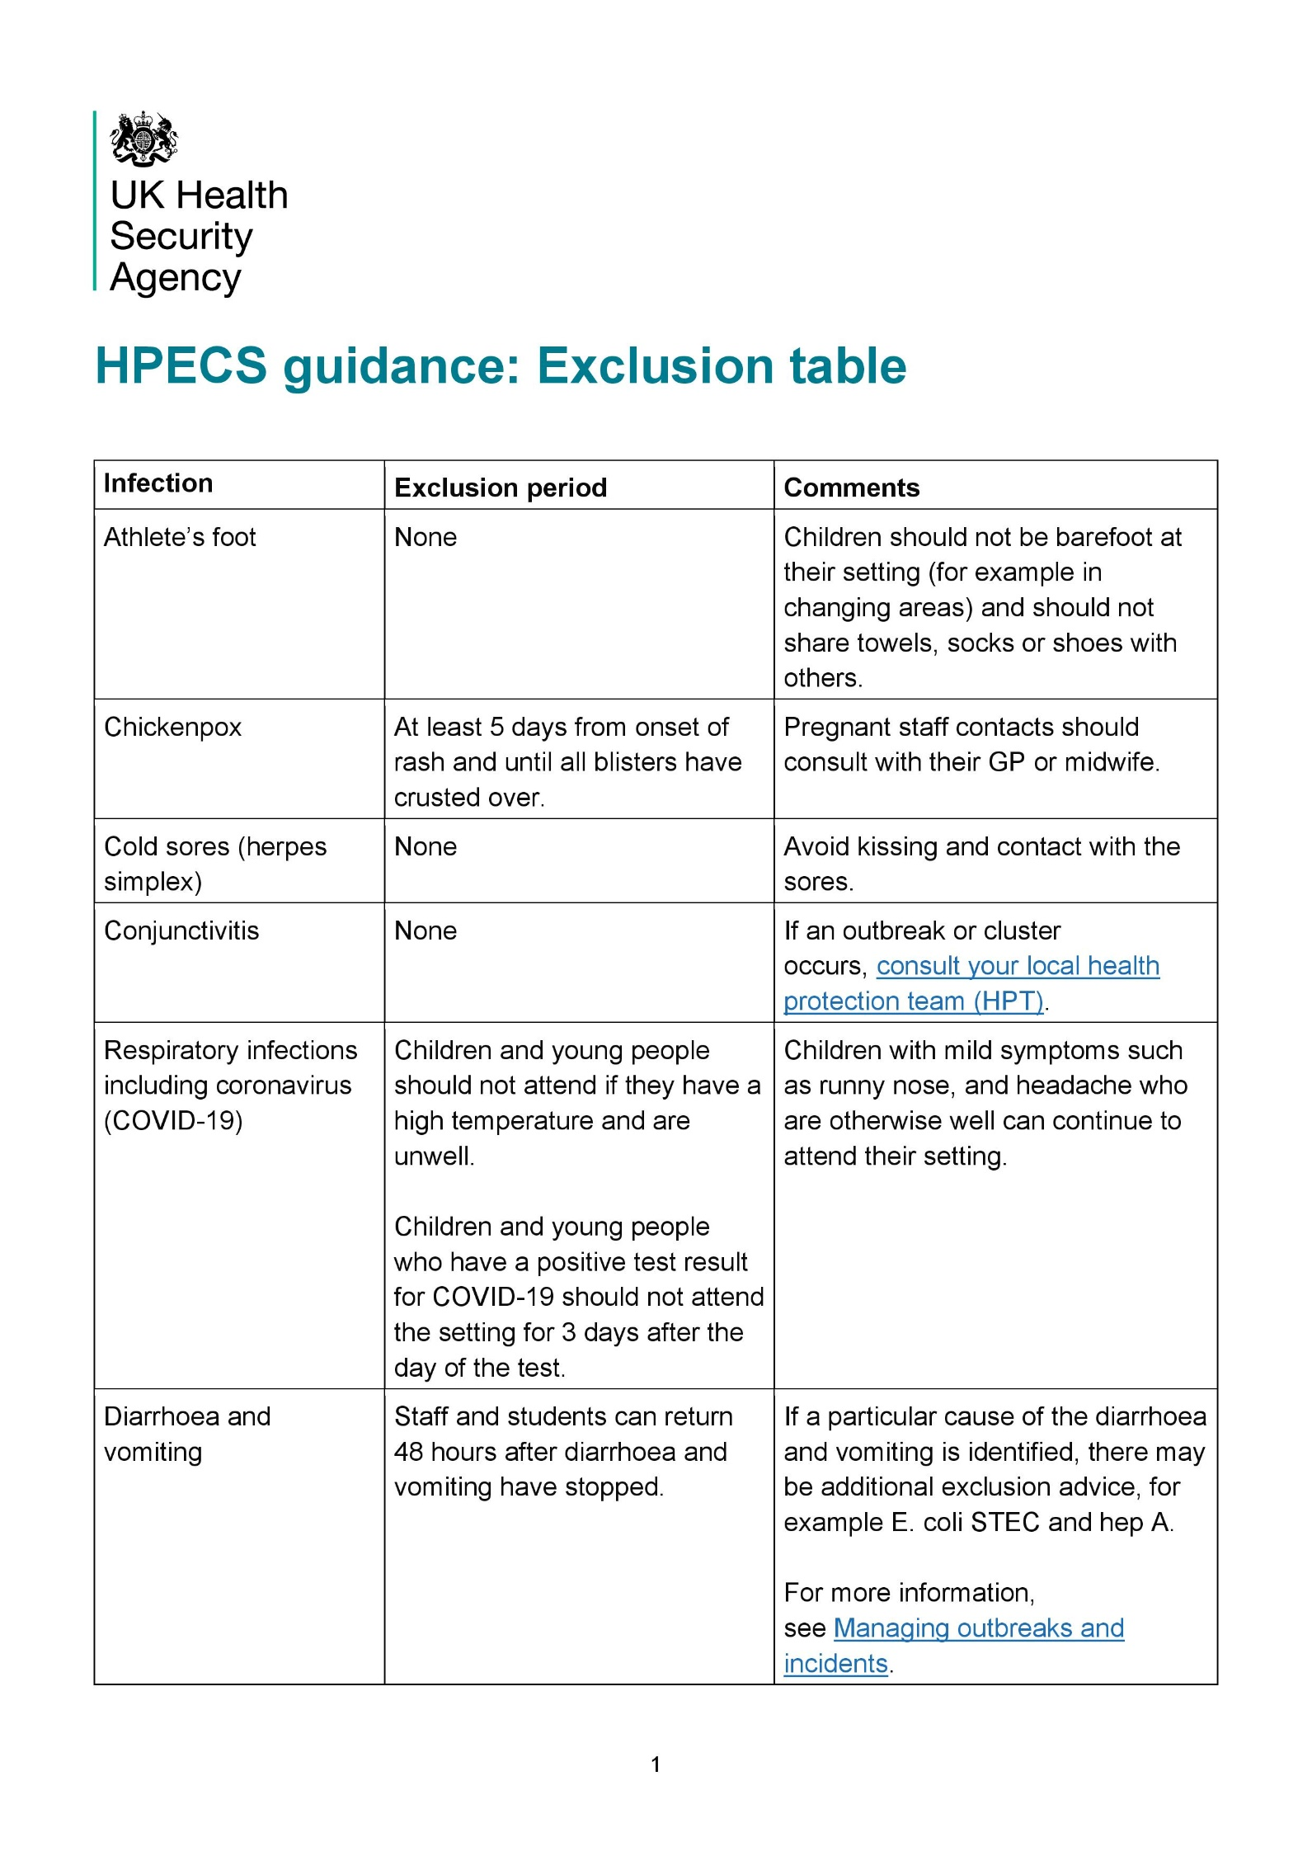

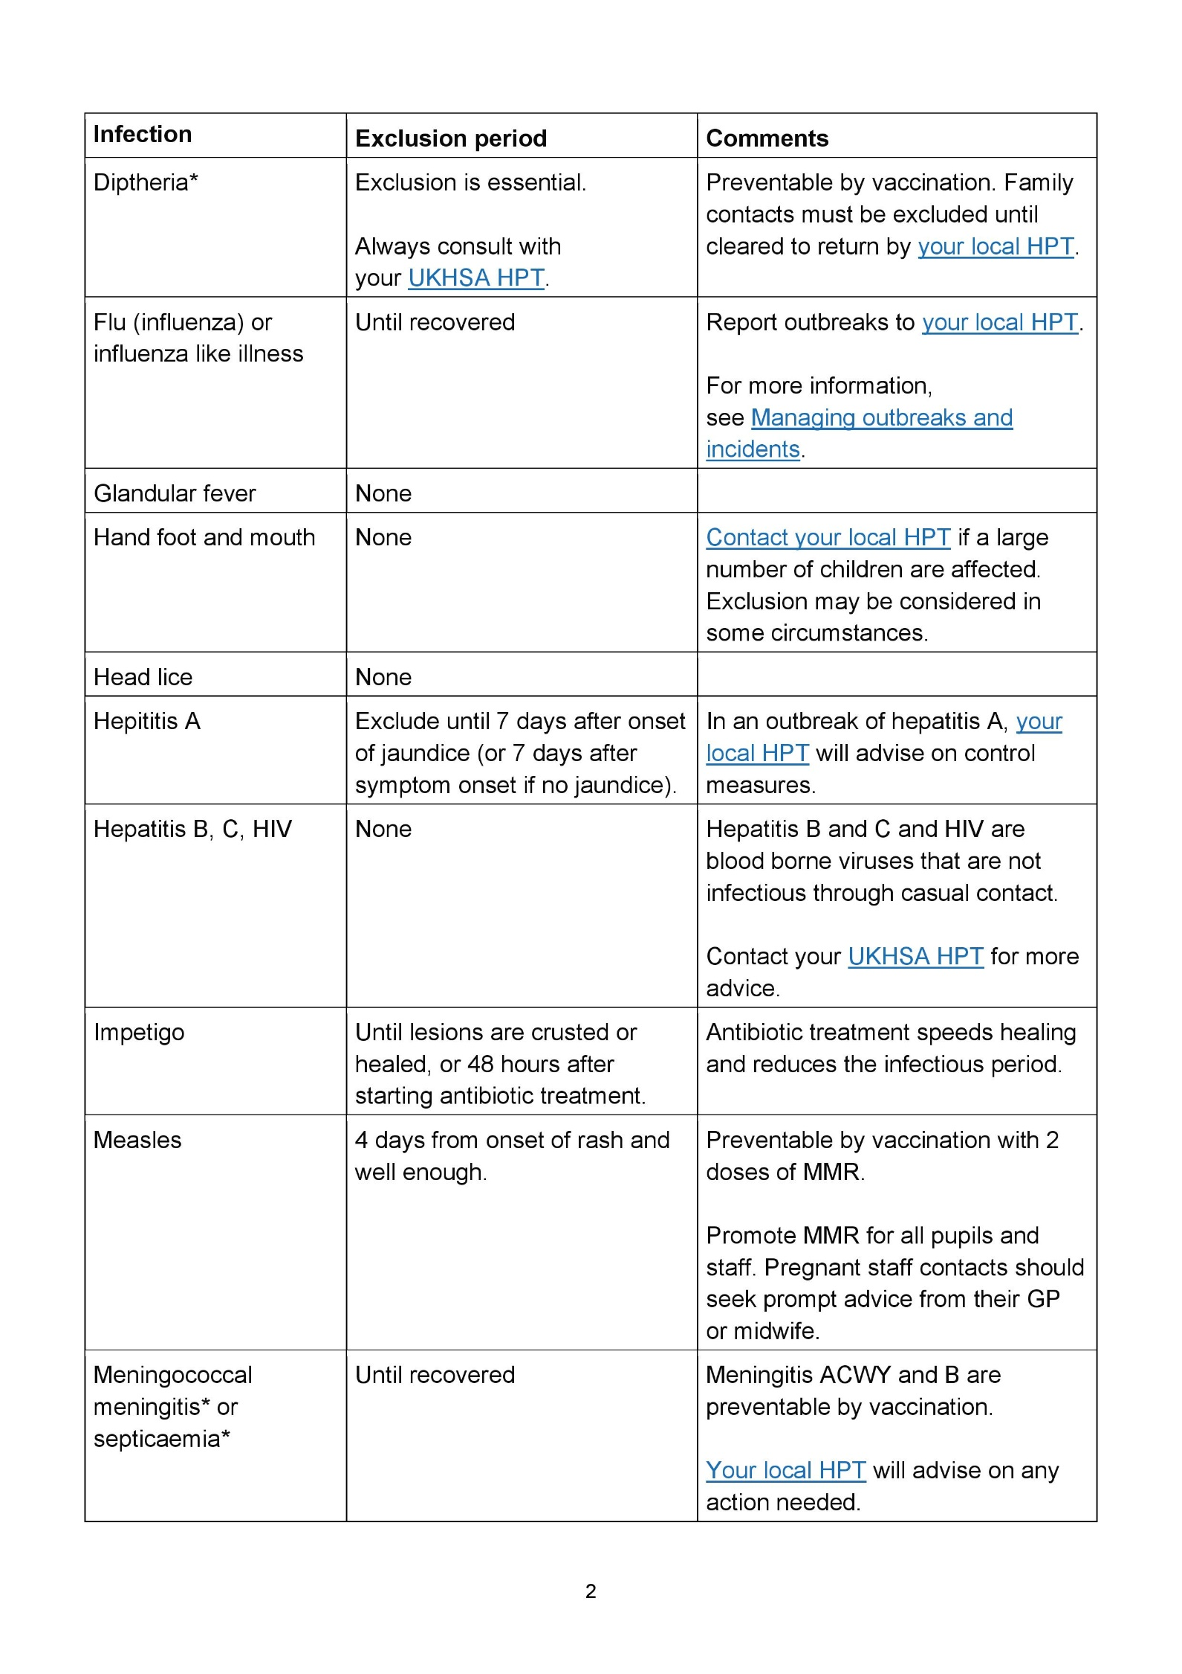
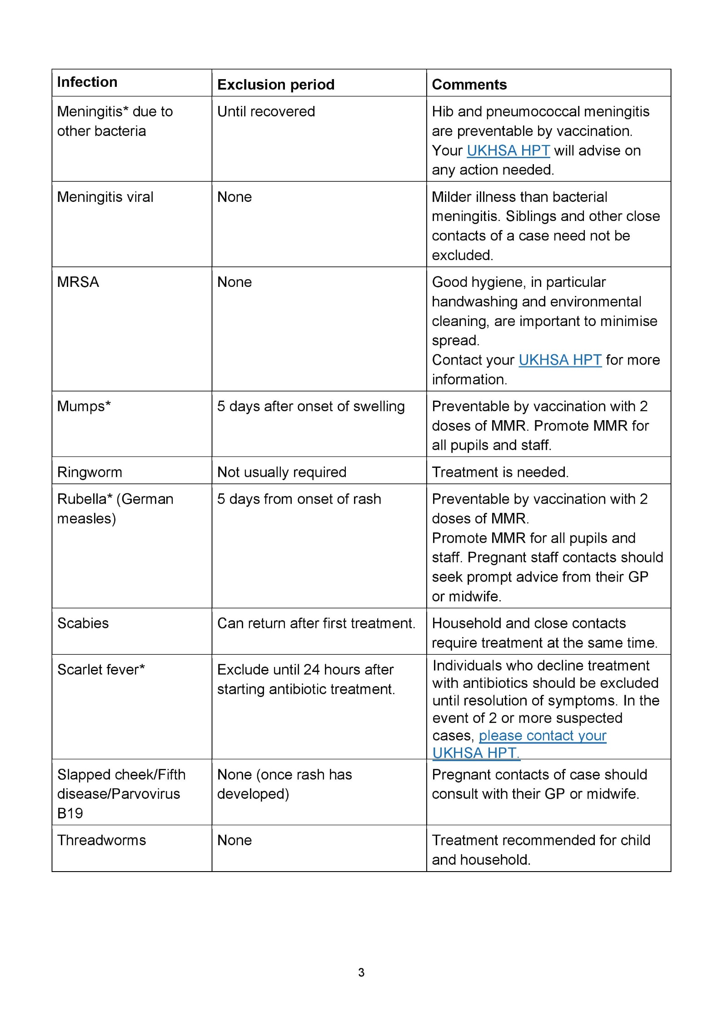
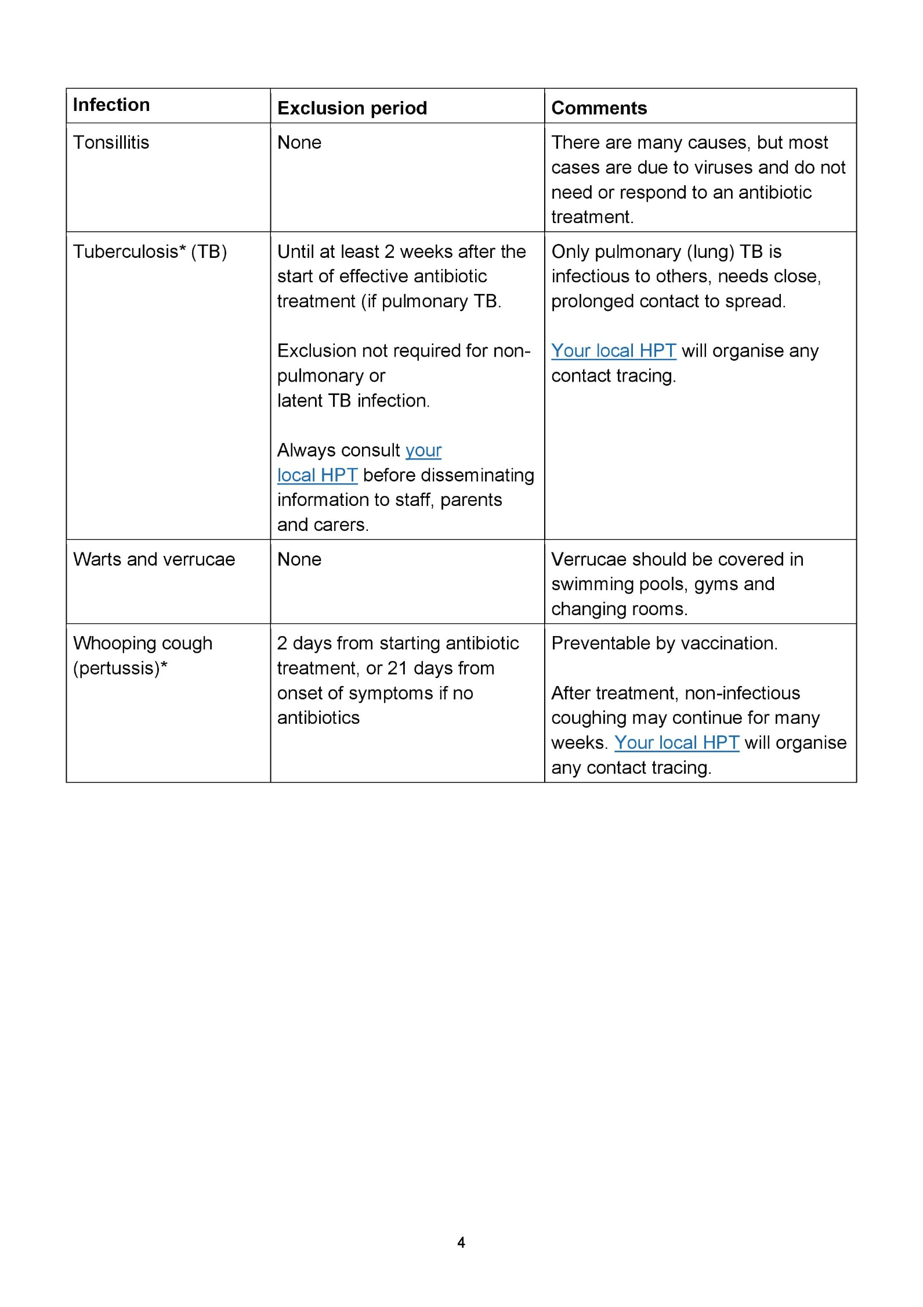

APPENDIX 2: MIDDLESBROUGH LA CODE OF CONDUCT – 24-25

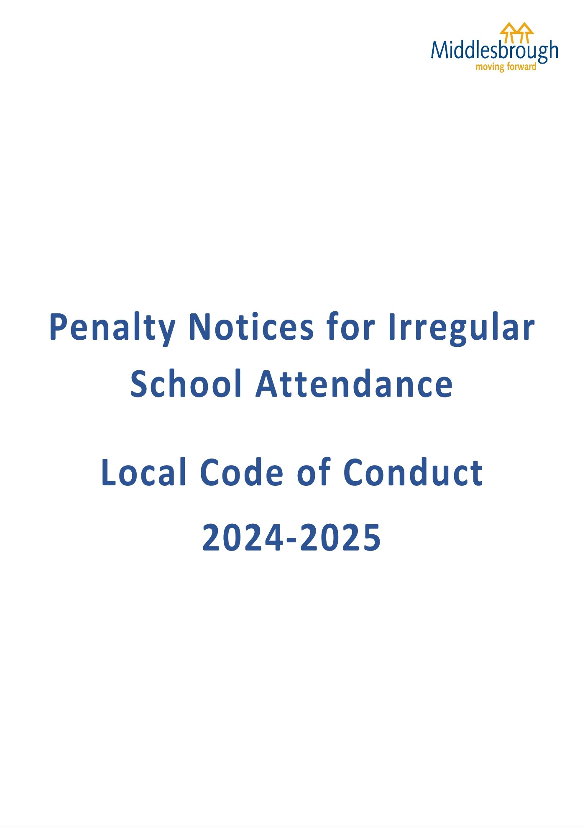

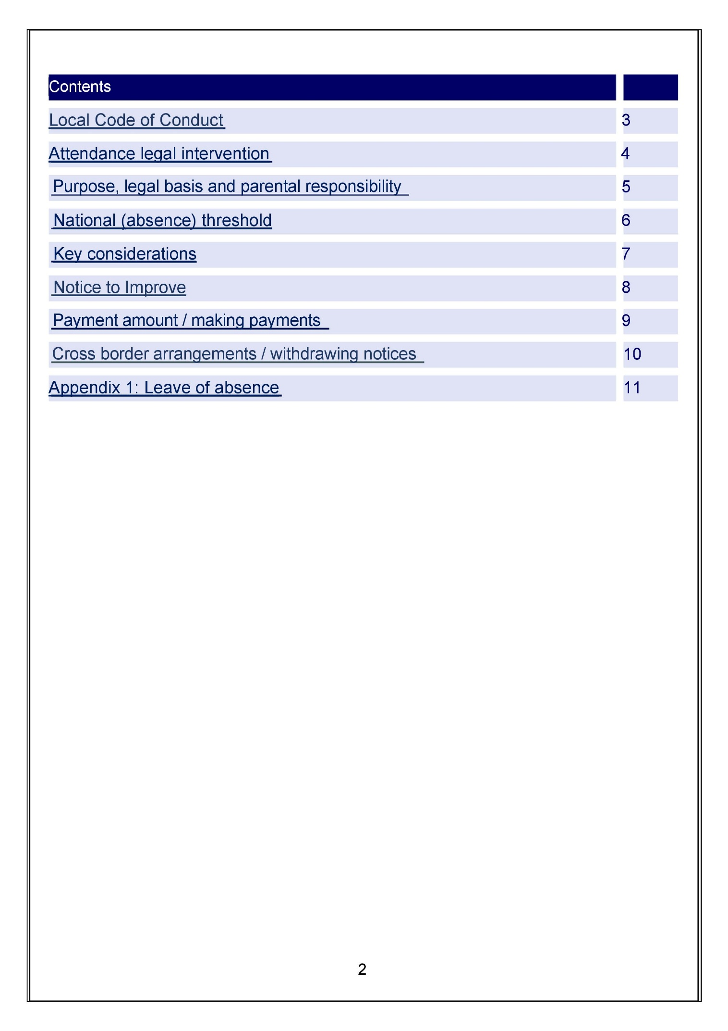
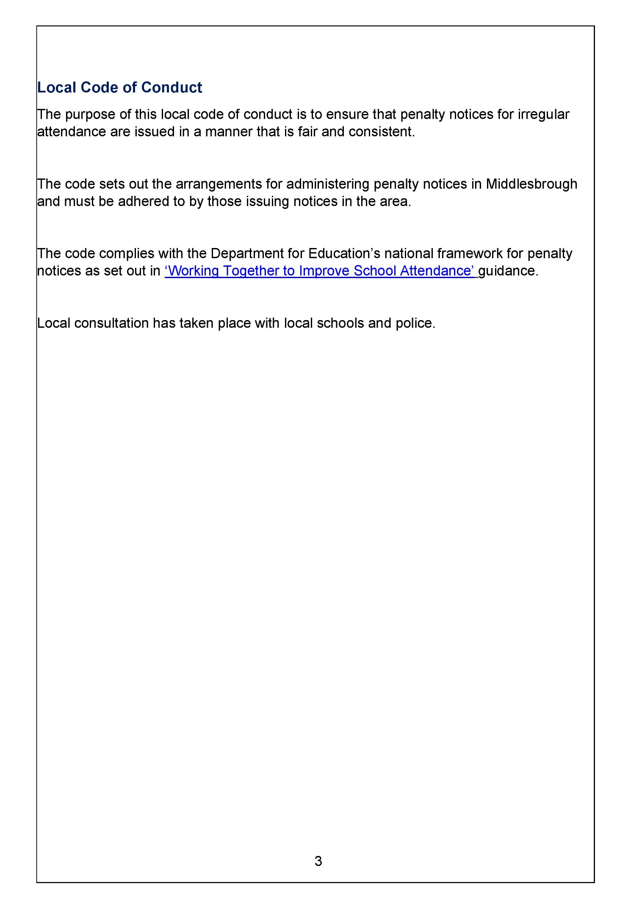
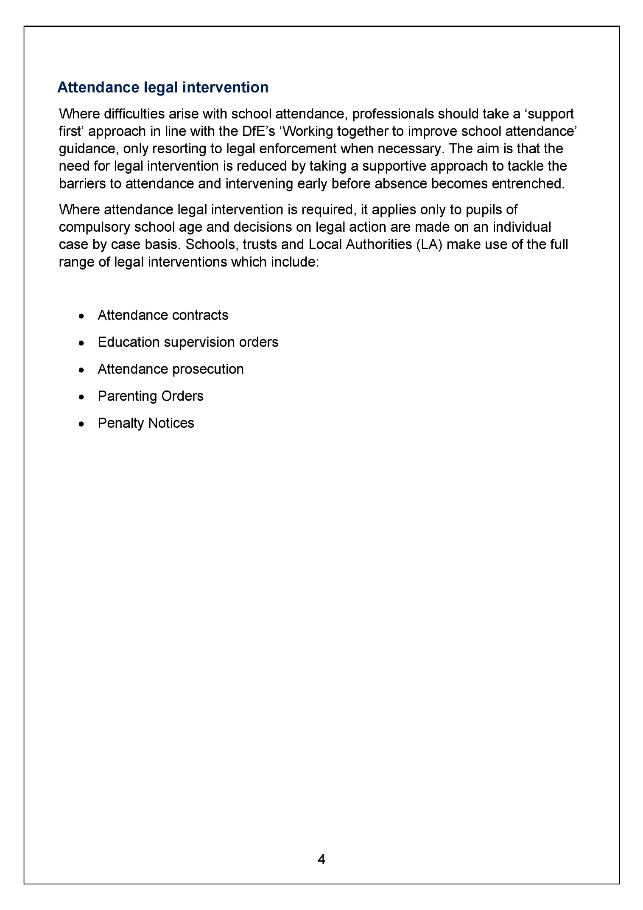
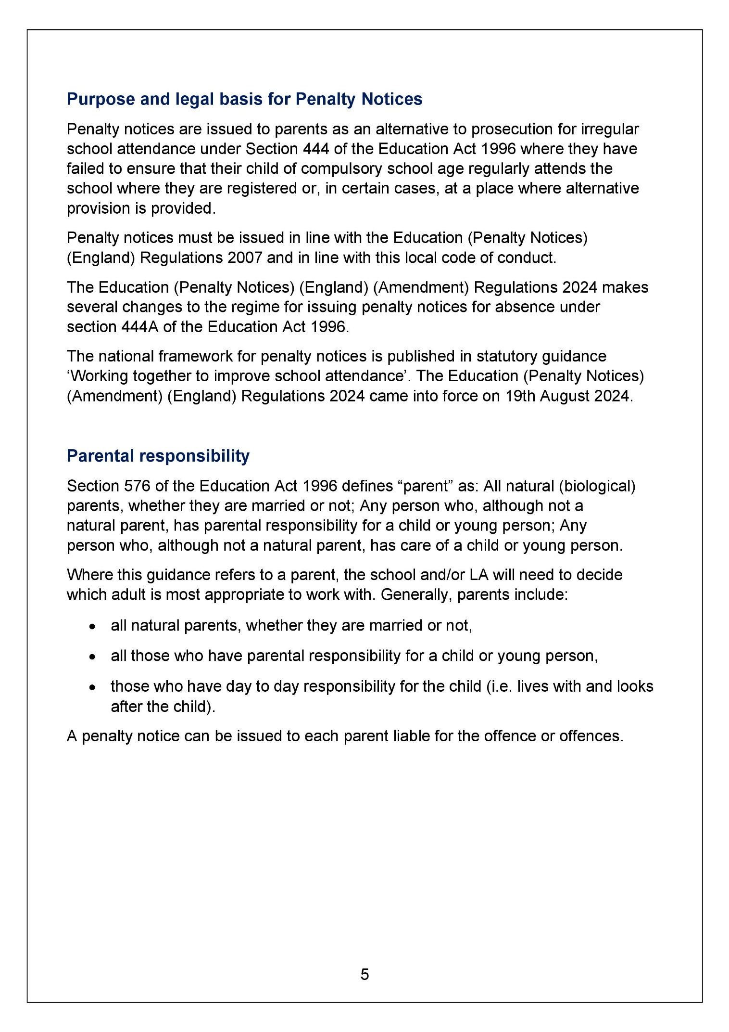
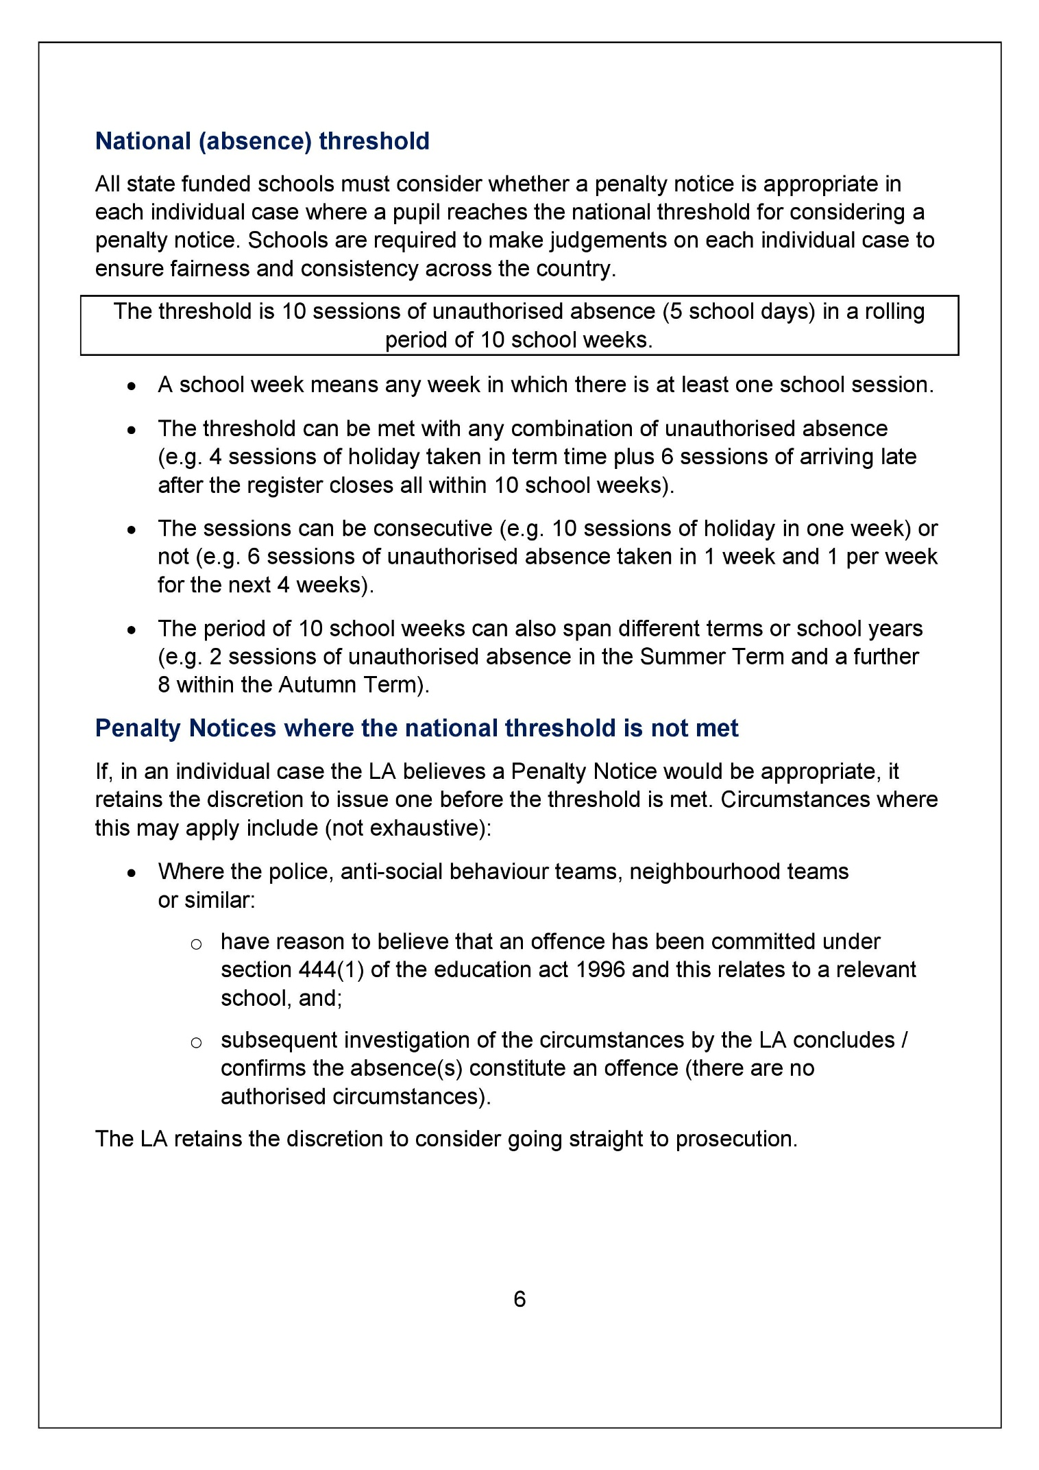
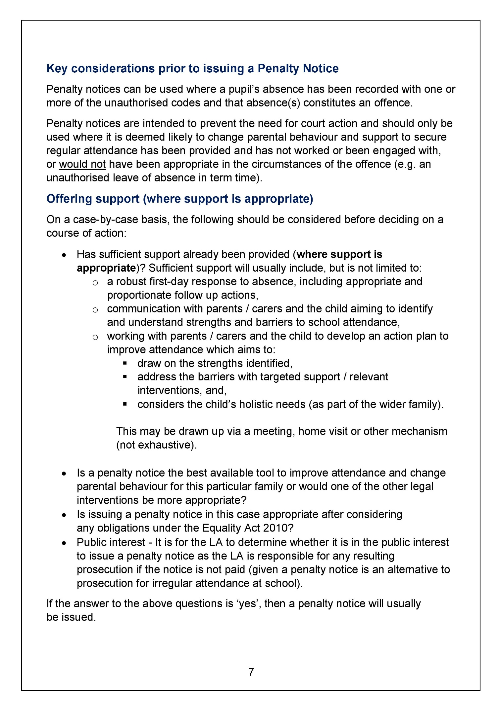
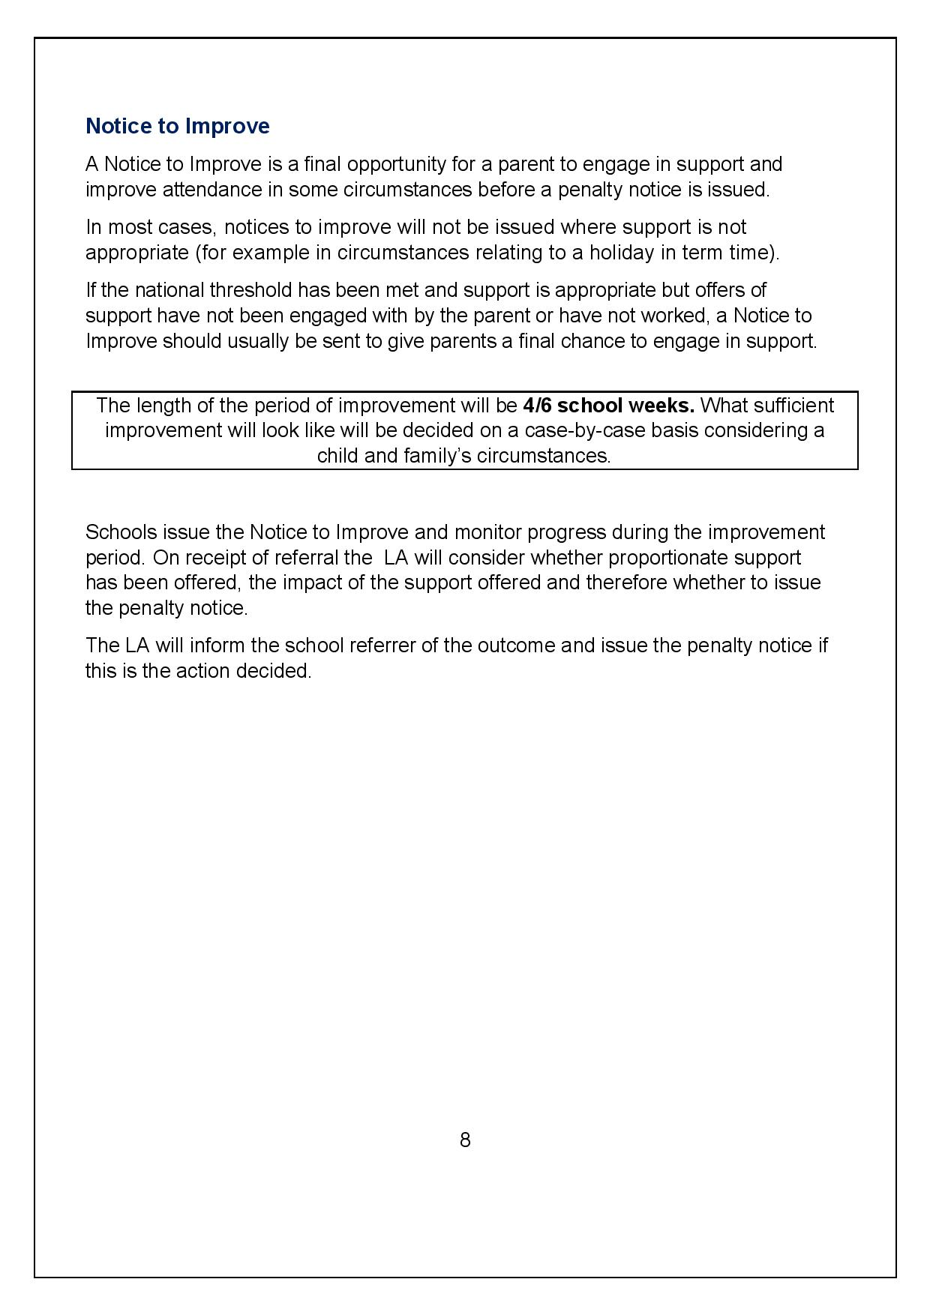
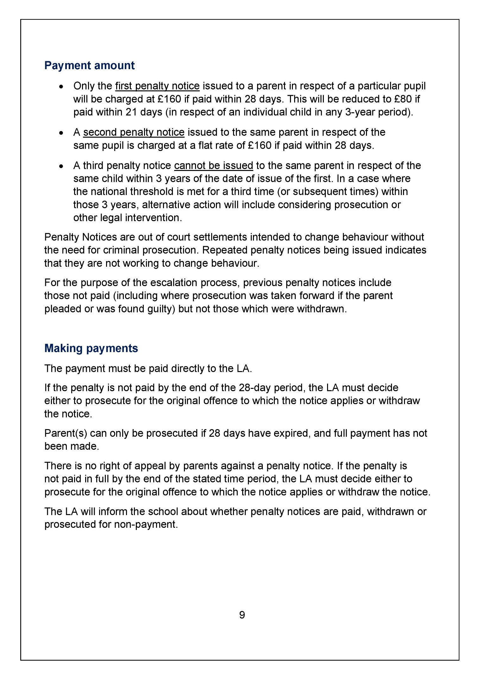
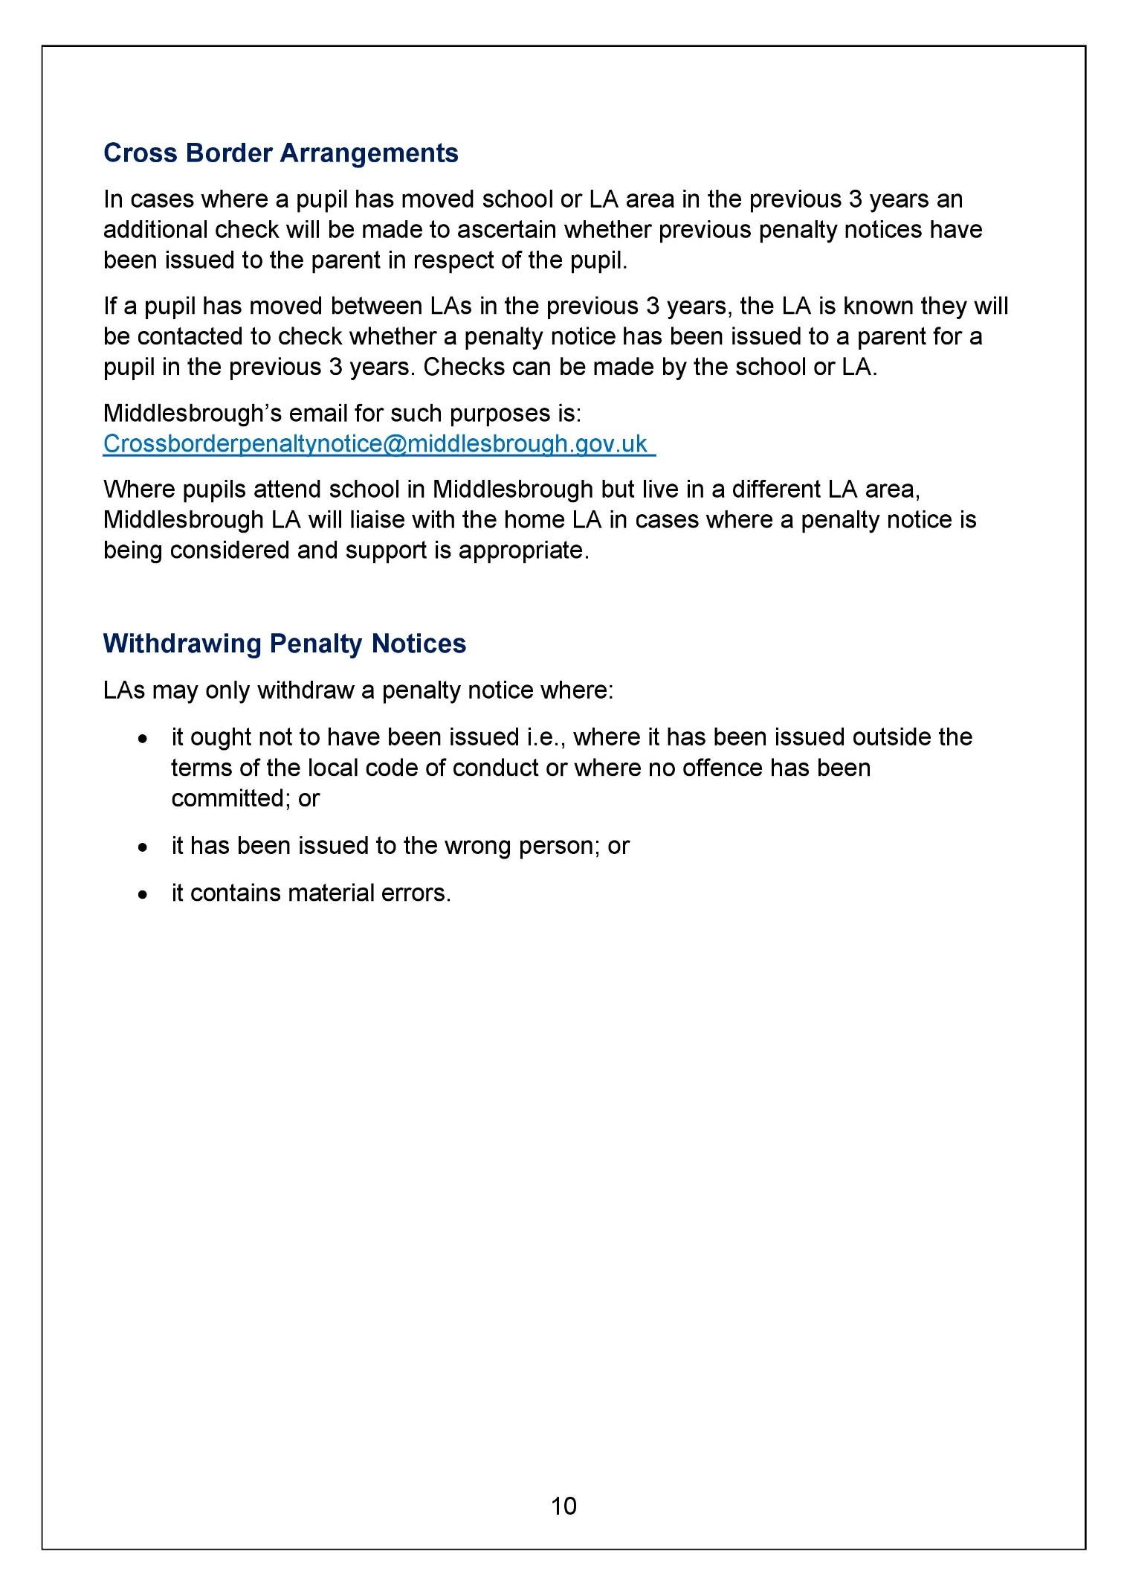
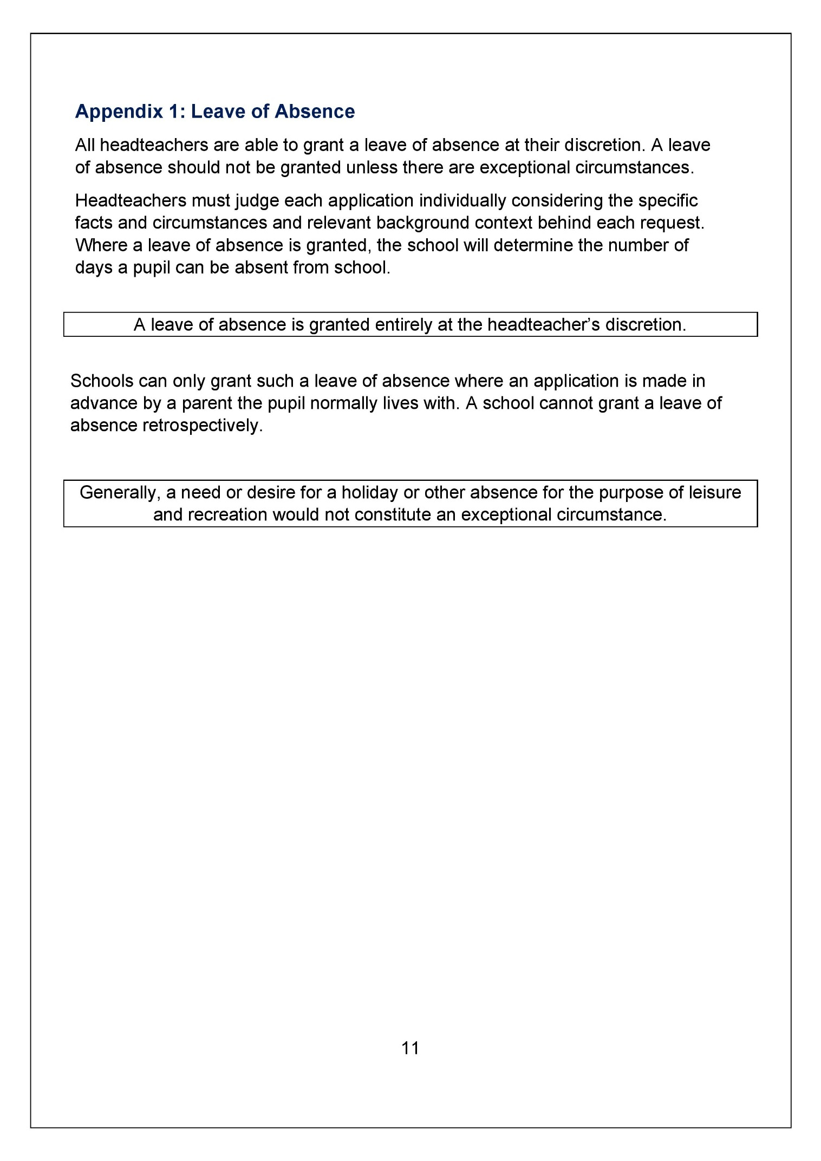

APPENDIX 3: REDCAR & CLEVELAND LA CODE OF CONDUCT – JULY 2024



Directorate of Children and Families

Penalty Notice Code of Conduct
(The Education Act 1996, The Anti-Social Behaviour Act 2003 and the Education (Penalty Notices) (England) Regulations 2007 as amended).
This Code applies to all maintained schools, Academies and Free Schools.

this is Redcar & Cleveland

Document Control

Ownership & Review

Name | Grant Smith
Title | Lead for Inclusion
Telephone | 01642 444348
Email | Grant.smith@redcar-cleveland.gov.uk

Approver | Clare Mahoney
Review Date | August 2025

Version Control
Version | Date | Author | Changes
2 | July 2024 | AWS | Updates from DFE Guidance Aug 2024

this is Redcar & Cleveland
- Rationale
  - Regular and punctual attendance of pupils at school is both a legal requirement and essential in order for pupils to maximise the opportunities available to them. The Redcar & Cleveland Attendance & Welfare Service (AWS) will continue to investigate cases of non-attendance from school and, following appropriate casework, instigate legal action if applicable. A Penalty Notice is an alternative to prosecution which does not require an appearance in court whilst still ensuring an improvement in a student’s attendance. Payment of a Penalty Notice enables parents to discharge potential liability for conviction. Following the implementation of Section 23 of the Anti-Social Behaviour Act 2003 it is possible that certain cases of unauthorised absence can be dealt with way by of a Penalty Notice. Penalty Notices will require the parent of a child of compulsory school age, whose attendance has been unsatisfactory, to pay a fine, £160 if paid within 28 days, and £80 if paid within 21 days.
  - In order to comply with Human Rights’ legislation, it is essential that Penalty Notices be issued in a consistent, fair and transparent manner and will be reviewed annually. In addition, the Education (Penalty Notice) (England) Regulations 2007 as amended requires a Local Authority to have in place a Code of Conduct which ensures that the power to use Penalty Notices is applied consistently and fairly and that suitable administrative arrangements are in place.

  - In line with Regulation 15 Governing Bodies, of the aforementioned regulations, Head Teachers and Chief Police Officer for the area have all been consulted with, with regards to the Code.

- Legislation

Personnel authorised to operate this Code must have regard to the following legislation and guidance:
• The Race Relations (Amendment) Act 2000
• Data Protection Act 2018
• Children Act 1989
• Crime and Disorder Act 1998
• Special Educational Needs and Disabilities Code of Practice 2015
• Education Act 1996
• The Education and Inspections Act 2006
• The Equality Act 2010
• The Education (Penalty Notice) (England) Regulations 2007 as amended
• The Education (Pupil Registration) (England) Regulations 2006 as amended

3 Framework for issuing Penalty Notices
3.1 National Threshold for the consideration of a Penalty Notice:
A Penalty Notice must be considered when the threshold is met; being 10 sessions of unauthorised absence in a rolling period of 10 school weeks.
The 10 sessions can either be as a result of unauthorised absence for a holiday taken in term time or any combination of unauthorised absences , such as a holiday in term time and sessions of arriving late after the register has closed.
The 10 sessions can be consecutive e.g. 10 sessions of a holiday in one week or non-consecutive e.g. 6 sessions of unauthorised absence taken in one week followed by 1 session of absence per week for the next 4 weeks.
The period of 10 school weeks can span different terms and different school years.

3.2 Is Support appropriate in the case?
When the threshold has been met to issue a Penalty Notice, schools must consider whether support is appropriate in the particular case and if so, school must continue with the support without issuing a Penalty Notice or
In cases where support being offered is not working or should the parent have failed to engage with the support offered, then a Notice to Improve should be issued.
Should support and/or a Notice to Improve failed to have worked, a Penalty Notice may be offered.
If support is not appropriate in the particular circumstances i.e. for unauthorised absences due to term time holiday a Penalty Notice should be issued subject to the following:
- Is a Penalty Notice the best available option to improve attendance and change parental behaviour or would another form of legal intervention be more suitable?
- Is the issuing of a penalty Notice in the ca appropriate considering any obligations under the Equality Act 2010 and;
- Whether it is in the public interest to issue a Penalty Notice.
If the answer is yes to the above, then a Penalty Notice may be issued.
Schools and Academies are expected to use a multi-agency approach, taking the views of the parents and children into consideration where possible and appropriate.
In cases where support is appropriate, consider on a case-by-case basis.
Has sufficient support already been provided?
Sufficient support will include first day calling, meeting with the child, meetings with parents, attendance action plan/attendance contracts, school plans, reasonable adjustments, signposting to single agency support, consideration of child’s special educational needs and a need for an EHCP, and to offer an Early Help Assessment where multi agency support is needed.
The following (non-exhaustive) methods would have been considered/used prior to the issue of a Notice to Improve:
• Home visits
• Meetings
• Referrals to other agencies for support

3.3 Notice to Improve:
A Notice to Improve is the final opportunity for a parent to engage with support before a Penalty Notice is considered.
If the national threshold has been met and support is appropriate, but offers of support have not been engaged with by the parent or have not worked, a Notice to Improve should be sent to the parents.
A Notice to Improve will not be issued where support is not appropriate, for example in the case of unauthorised absences a result of holiday.
An authorised officer can choose not to issue a Notice to Improve.

The Notice to Improve should include:

a. The pupil’s attendance record and details of the offence(s)
b. The benefits of regular attendance and parents’ duty under section 7 of the Education Act 1996
c. Detail the support provided so far.
d. Opportunities for further support and the option to access previously provided support that was not engaged with if appropriate
e. A clear warning that a penalty notice may be issued, or prosecution considered if an improvement in attendance is not secured within the improvement period
f. A clearly specified timeframe for the improvement period of between 3 and 6 weeks.
g. Details of what sufficient improvement within that timeframe will look like in the case “e.g. no unauthorised absence within the specified period.’’
h. The grounds on which a penalty notice may be issued before the end of the improvement period.
What sufficient improvement looks like will be determined on a ‘case by case’ basis and should be specified in the Notice to Improve.
If sufficient improvement is not made, then the Local Authority may issue a Penalty Notice.
Where it is apparent that sufficient improvement is not being made e.g. where a Notice to Improve states that there should be no authorised absences recorded during a 6-week period, but unauthorised absences are recorded at the start of the period, then a Penalty notice can be issued before the expiry of the improvement period.
If a penalty notice is to be issued before the end of the improvement period, the parent must be informed before it is issued.
If no Service Level Agreement is in place the school/ academy would be expected to issue the “Notice to Improve”.
3.4 2.4 Procedure for issuing a Penalty Notice
3.4.1 It has been locally agreed that within Redcar and Cleveland, Penalty Notices will only be issued by the Attendance & Welfare Service following authorisation from the Senior Attendance Welfare Officer or the Lead for Inclusion. This will ensure that duplicate notices will not be issued or when proceedings for an offence under Section 444 Education Act 1996, have already been commenced. Requests to issue notices from other authorities will also only be considered and authorised by the Senior Attendance Welfare Officer or the Lead for Inclusion. In any case where the penalty is not paid within the appropriate period, the AWS reserves the right to instigate action through the courts as required by legislation.
3.4.2 Penalty Notices should be issued to the parent or parents who have allowed the absence (regardless of which parent has applied for a leave of absence).
3.4.3 The amount payable under the first Penalty Notice is £160 if paid within 28 days beginning on the date which the notice is received. This will be reduced to £80 if paid within 21 days ,beginning on the date which the notice is received.
3.4.4 Any second penalty notice issued to the same parent for the same child within a rolling 3-year period will be charged at a higher rate of £160 with no option for this second offence to be discharged at the lower rate of £80.
3.4.5 No one parent will receive more than 2 penalty notices for the same child within a rolling 3-year period, so at the 3rd (or subsequent) offence(s) other options will be considered (such as prosecution or one of the other attendance legal interventions).
3.4.6 For the purposes of the 2.4.5 those penalty notices which were issued, but were subsequently withdrawn, will not be included.
3.4.7 Where a child has moved school and/or local authority area within the previous 3 years, an additional check will be made of the schools/local authorities to establish whether any previous penalty notices have been issued.
3.5 The Attendance & Welfare Service will consider requests to issue Penalty Notices from schools/colleges in Redcar & Cleveland and neighbouring local authorities. The Attendance & Welfare Service will action these requests providing:
- The circumstances of the case meet the criteria for the issue of a Penalty Notice which are specified in this Code of Conduct, and
- All necessary information is provided to the Attendance & Welfare Service in order to establish that an offence, under Section 444(1) Education Act 1996, has been committed.

In cases requiring the issue of a Penalty Notice(s), each parent will receive a separate Penalty Notice for each child. Should a parent fail or refuse to pay any Penalty Notice issued for this reason, then the evidence provided by the school/college will be the only information laid before the court.

3.6 Penalty Notices will not be issued during Truancy Patrols if they are instigated as this could be a health and safety risk. Additionally, not all the information will be available to prove the offence at that time.

3.7 In cases requiring the issue of a Penalty Notice(s), each parent will receive a separate Penalty Notice for each child. Should a parent fail or refuse to pay any Penalty Notice issued for this reason, then the evidence provided by the school/college will be the only information laid before the court.

3.8 Penalty Notices will not be issued during Truancy Patrols if they are instigated as this could be a health and safety risk. Additionally, not all the information will be available to prove the offence at that time.

For further information on statutory duties see Annex 2

The local authority reserves the right to issue a Penalty Notice outside of the framework should the circumstances of a particular case warrant it, for example if several term time holidays are taken which hare below the threshold, or for repeated absences, such as birthdays.

4. General criteria for the issuing of a Penalty Notice

For issues of non-school attendance (contrary to Section 444(1) of the Education Act 1996):

4.1 Where concerns arise regarding the attendance of a child the Attendance and Welfare Service may consider issuing a parent (s) with a Notice to Improve in the following (non-exhaustive) circumstances:

- Where a child, during a rolling 10-week school period has had at least 10 unauthorised absence marks recorded on the attendance register. or;

- The parent has a previous conviction for an offence contrary to section 444 of the Education Act 1996 or;
- Where the parent of a child continually fails to provide a reasonable or acceptable explanation for a pupil’s absence.
Before a decision is made regarding the issue of a penalty notice:
If the school have a service level agreement with our Attendance and Welfare Service, we will endeavour to support parents in ensuring the regular school attendance of their children. We will use a multi-agency approach, taking the views of the parents and children into consideration where possible and appropriate.
To do this the following (non-exhaustive) methods would have been considered/used prior to the issue of any Notice to Improve:
- Home visits
- Meetings
- Referrals to other agencies for support

If no Service Level Agreement is in place the school/ academy would be expected to issue the “Notice to Improve”.
Schools and Academies are expected to use a multi-agency approach, taking the views of the parents and children into consideration where possible and appropriate.
In cases where support is appropriate, consider on a case-by-case basis.

Has sufficient support already been provided?
Sufficient support will include first day calling, meeting with the child, meetings with parents, attendance action plan/attendance contracts, school plans, reasonable adjustments, signposting to single agency support, consideration of child’s special educational needs and a need for an EHCP, and to offer an Early Help Assessment where multi agency support is needed.
The following (non-exhaustive) methods would have been considered/used prior to the issue of a Notice to Improve:
• Home visits
• Meetings
• Referrals to other agencies for support

4.2 In the aforementioned circumstances, a Notice to Improve may be issued to parent(s), advising that in order to avoid a Penalty Notice being issued to them the student should record no unauthorised absences during a specific period. Parent(s) should receive the warning letter no later than three days before the monitoring period commences. This period will be monitored before a decision with regards to issuing a penalty notice or not to issue a penalty notice is made.

The Notice to Improve should include:

a. The pupil’s attendance record and details of the offence(s)
b. The benefits of regular attendance and parents’ duty under section 7 of the Education Act 1996
c. Support/opportunities for support provided so far
d. Opportunities for further support and the option to access previously provided support that was not engaged with if appropriate
e. Risk of a penalty notice being issued, or prosecution considered if improvement is not secured within the improvement period
f. A clear specified timeframe for the improvement period of between 3 and 6 weeks.
g. Details of what sufficient improvement within that timeframe will look like in the case “e.g. no unauthorised absence within the specified period.’’
h. The grounds on which a penalty notice may be issued before the end of the improvement period.

If sufficient improvement is not made and there are 10 sessions (usually equivalent to 5 school days) of unauthorised absence within a rolling 10 school week period, then the Local Authority may issue a Penalty Notice.

The local authority will also take into consideration any instance where it appears a parent deliberately or wilfully acted to circumvent the manner in which this policy operates.

4.3 For issues of unauthorised absence:

- A separate Leave of Absence Policy applies, and consideration is given for issuing Penalty Notices during the following:
- 10 sessions (usually equivalent to 5 school days) of unauthorised absence within a rolling 10 school week period

For further information on statutory duties see Annex 1

5 Procedure for withdrawing Penalty Notices

5.1 A Penalty Notice may be withdrawn by Redcar & Cleveland Local Authority in any case in which the authority determines that:
(a) it should not have been issued, or
- it should not have been issued to the person named as the recipient, or
- it contains material errors or
- Where a notice is not paid, and the authority decides not to prosecute. In such circumstances the regulations require that the penalty notice is withdrawn.

5.2 Where a Penalty Notice has been withdrawn in accordance with the above, a notice of the withdrawal shall be given to the recipient and any amount paid by way of penalty in pursuance of that notice shall be repaid to the person who paid it. No proceedings shall be continued or instituted against the recipient for the offence in connection with which the withdrawn notice was issued or for an offence under Section 444(1) of the Education Act 1996 arising out of the same circumstances.

6. Payment of Penalty Notices
Methods of Payment:
- By Credit or Debit card

- Internet: Go to https://www.civicaepay.co.uk/Redcar/Webpay_Public/Webpay/Default.aspx
and select “Education Fine” on the left hand side to make a card payment 24/7.

- Telephone the Contact Centre on 01642 774774 to make a card payment during office hours.

7. Appeal
There is no statutory right of appeal once a notice has been issued.

8. Administration of the Penalty Notice Scheme
All financial penalties are payable to Redcar and Cleveland Council. Regulation 23 of the aforementioned regulations prescribe that sums received through the payment of penalty notices should be used for the issuing and enforcing of the penalty notices and prosecuting recipients who fail to pay the notices.

Annex 1 Statutory Duties
1. Statutory Duties of Redcar and Cleveland Council
1.1 The Local Authority is a relevant enforcer for the purposes of the Education Act 1996. Enforcement can be affected through a number of formalised routes including Penalty Notices and prosecution of parents/carers for irregular attendance and School Attendance Orders.
1.2 Redcar and Cleveland Council employs a core group of personnel to ensure these statutory duties are met and quality assured.
1.3 The areas of legislation that Redcar and Cleveland Council has responsibility for include:
• School Attendance Order - Section 437 Education Act 1996. If it appears to Redcar and Cleveland Council that a child of compulsory school age in the area is not receiving suitable education, either by regular attendance at school or otherwise, a notice will be served in writing to the parent(s) requiring them to satisfy the Local Authority (LA) within a period specified in the notice that the child is receiving such education.
• Prosecution under Section 444(1) and 444(1A) Education Act 1996. If a child of compulsory school age who is a registered pupil at a school is failing to attend regularly at the school, parent(s) may be guilty of an offence.
The term 'compulsory school age' is the period of time in a child or young person's life during which a parent or guardian has a duty to provide an education, for example, by sending them to school or by providing home schooling
• Penalty Notices (inserted into sections 444A and 444B of the Education Act 1996 by section 23 Anti-social Behaviour Act 2003; and Section 105 of the Education and Inspections Act 2006). Empowers designated LA officers, head teachers (deputy and assistant headteachers authorised by them) and the police to issue Penalty Notices in cases of unauthorised absence from school, and for parental failure to ensure that their child is not present in a public place during school hours without reasonable justification during the first five days of exclusion. Redcar and Cleveland Council has written a Code of Conduct which specifies how Penalty Notices will be issued.
• Education Supervision Orders (ESO) pursuant to section 36 (The Children Act 1989). Before instituting proceedings for an offence of irregular attendance or failure to comply with a school attendance order, the Education Act requires that the LA consider whether it would be appropriate to apply for an ESO instead of, or as well as, prosecuting the child's parents.
2. Statutory Duties of Schools and Academies
2.1 Schools’ responsibilities relating to attendance are detailed in the Education (Pupil Registration) (England) Regulations 2006 as amended. These responsibilities include:
• Advising Redcar and Cleveland Council of any pupil who fails to attend regularly or has had 10 or more days of continuous unauthorised absence;
• Taking a register twice each day (at the start of the morning session and once during the afternoon);
• Marking pupils for each session indicating, with the appropriate code, whether each was present, absent, engaged in an approved educational activity off-site or unable to attend due to exceptional circumstances (unavoidable school closure, lack of school/LA transport and not within walking distance or widespread travel disruption due to local/national emergency); and
• Complying with statutory registration & deletion procedures.
2.2 Where there are concerns about pupil absence, schools should seek to intervene early and maintain a chronology and record of all contacts regarding pupil absence with the pupil, parent and other agencies. This is of great importance, as schools will be required to produce this as evidence if legal intervention is subsequently used.
2.3 For the purposes of school attendance, the term ’parent’ means all natural parents, whether they are married or not and includes any person who, although not a natural parent, has parental responsibility (as defined in the Children Act 1989) and any person who, although not a natural parent, has care of a child or young person.
2.4 Registration is a key aspect of excellent practice. Registers are legal documents and school leaders should ensure systems for recording attendance and absence is always accurate. Schools should maintain an up-to-date knowledge of pupil registration regulations by accessing information from the Department for Education (DfE) website. The DfE provides guidance on the use of National Attendance Codes which are used when completing the school census.
2.5 Where a Headteacher/Externally employed Attendance Agency wishes to refer a matter to Redcar and Cleveland Council for legal proceedings to be considered under s444 (1) or (1A) Education Act 1996, they should complete the EW1 Single Agency Referral Form
(SARF) form which can be located here:

Annex 2 Process for Requesting Penalty Notice(s) in Respect of Unauthorised Leave
• Headteacher receives request from parent to grant permission for leave during term time OR Headteacher is notified that a family has taken a family holiday without seeking prior permission.
• Headteacher considers whether the request could be considered to fall under the heading of ‘exceptional circumstances’. The headteacher may request additional information to support this consideration. If the request is not being made as a result of ‘exceptional circumstances’ OR where no request for leave is sought, then the Headteacher must notify the parent, in writing, of their decision to refuse to grant permission for leave. The code for this absence must be unauthorised, and parents must be informed that any refusal to adhere to this decision places the parent(s) at risk of being issued with Penalty Notice(s), as per Redcar and Cleveland Council procedure/Code of Conduct.
• Headteacher to await the response of parent(s) and, if the family holiday goes ahead, during term time, then the period of absence must be clearly recorded as ‘G’ on the official attendance register (thus ensuring that it is recorded as an unauthorised family holiday);
• Once the student has returned to school, Headteacher to complete the EW1 Single Agency Assessment Form (SARF). Evidence to be included:
1. The letter sent to parent(s) notifying them that the absence would not be authorised and warning them that the matter would now be passed to the Local Authority;
2. A copy of the student’s registration certificate which clearly shows the period of absence which has been coded as G (unauthorised family holiday) or “0” (unauthorised absence).
3. A copy of the student’s registration certificate to show 10 sessions (usually equivalent to 5 school days) of unauthorised absence within a rolling 10 school week period.
4. A copy of School/Academy Leave of Absence Policy .
Upon receipt of the relevant documentation, the Attendance and Welfare Team will check to determine whether the criteria to issue a Penalty Notice to each parent in respect of the unauthorised leave has been met. Penalty Notices will be sent by way of first-class post. Each Parent will be given 21 days to pay £80 for each child, should the fine(s) fail to be paid it will double to £160 and the parents will be given a further 7 days to make payment in full. Parents failing to pay within 28 days will face prosecution under section 444 Education Act 1996.
Any second penalty notice issued to the same parent for the same child within a rolling 3-year period will be charged at a higher rate of £160 with no option for this second offence to be discharged at the lower rate of £80.
Where court proceedings are instigated as a result of non-payment, the Attendance and Welfare Service will be responsible for providing a section 9 witness statement. The Headteacher of the relevant school will be required to provide a signed statement of attendance, a proforma of which will be provided to the Headteacher by our court file administrator. If you have any queries/questions in relation to this process, please do not hesitate to contact the Attendance and Welfare Team on AWS@redcar-cleveland.gov.uk.
The Attendance & Welfare Service will update schools and Academies regarding the outcome of a SARF and subsequent action taken.

Annex 3 Evidential and Public Interest Tests
1. Evidential Test
1.1 In each case the Council will consider whether there is a realistic prospect of conviction. This will involve considerations of whether evidence (e.g. copies of the registers, statements, letters reports) is admissible, reliable, and credible. If a case does not pass the evidential stage, it must not proceed, no matter what level of non-attendance is involved.
1.2 The Council officers will consider any information presented by the parent in order to ascertain whether any of the statutory evidence are likely to be available.

2. Public Interest Test
2.1 Prior to undertaking any enforcement action, each individual case will be assessed to ensure that it is in the public interest to proceed. A prosecution will not usually take place if the prosecutor is satisfied that the public interest factors tending against prosecution outweigh those tending in favour of a prosecution.
2.2 Subject to receiving relevant information, the Council will consider whether there are any factors which tend to lower the culpability of the parents concerned or otherwise suggest that it may be disproportionate or unreasonable to proceed with a criminal case.
2.3 It should be understood that the presence of any public interest mentioned below (or a combination of them) is not determinative of whether a criminal prosecution should proceed be permitted to proceed. However, the following is a nonexclusive list of factors which if present and known to the LA Officer may be considered by the relevant officer considering the public interest test.
Sample factors which tend to suggest that a prosecution might not be in the public interest
1. | Very high levels of attendance | It is settled law that attendance, otherwise than in accordance with the schools’ rules, is not “regular attendance”. However, it is acknowledged that if the overall percentage of attendance is particularly high (e.g. over 96% over a given school term) then it may not be in the public interest to pursue a prosecution.
2. | Temporary health issues with the concerned Parent | If a parent is temporarily ill and this was the cause of the child’s absence it may suggest that repetition of the non-attendance is less likely. A low likelihood of a repetition is likely to suggest that the public interest is not served by a prosecution.
3. | Relevant health or psychological issues with the child | It is recognised that psychological factors the child may inhibit the child from attending school regularly:- • Stress and anxiety; • Socialisation problems; • Bullying whilst at school. If these factors are present it may suggest that other interventions rather than a criminal prosecution of the parent have a better prospect of assisting in achieving regular attendance.
4. | Temporary family difficulties:- | Relationship breakdown; Domestic abuse, Substance / alcohol abuse; Financial pressures; It is recognised that in temporary situations of exceptional hardship may suggest the Council may wish to consider a broader range of options rather than criminal prosecutions.
5. | The age of the child | If a child is almost 18 years of age, there may be limited benefit in prosecuting.
6. | Issues related to destabilisation of the family unit | It is recognised that certain parents in certain professions may face substantial prejudice as a result of receiving a criminal offence (particularly a recordable criminal offence).
Sample factors which tend to suggest that a prosecution may be the public interest
1. | Very poor levels of attendance | If the level of attendance is particularly poor then a criminal prosecution may be entirely necessary and proportionate.
2. | Parental knowledge of a child’s none-attendance. | Although the question of a parent’s knowledge is strictly only a component of the aggravated offence under Section 444(1)(a), it would aggravate any offending if the parent knew of the non-attendance and failed to take any steps to curtail the none-attendance.
3. | A lack of engagement by the parent with relevant educational authorities | The Local Authority aims to work in partnership with those they seek to regulate. A lack of engagement by the parent may suggest that a more formal means of enforcement is necessary.
4. | Previous convictions for the same offence | Previous convictions may suggest that the parent has a clear understanding of their legal duties but has continued to permit none-attendance.

If Redcar and Cleveland determines it is not appropriate or in the public interest to proceed with a prosecution, it will inform the school setting out the reasons why.

this is Redcar & Cleveland

APPENDIX 4: DfE ATTENDANCE CODES AND DESCRIPTORS 2024

DfE School Attendance Codes 2024

Present Codes
/ \ | present during registration
B | educated off site and taster days and do not fit K, V, P or W codes
K | attending provision arranged by the local authority
L | arrived after the register has started but before it has closed
P | Sporting activity with prior agreement from school
V | educational visit or trip
W | work experience
Absent Codes
Authorised Absences
C | exceptional circumstances
C1 | in a regulated performance/undertaking regulated employment abroad
C2 | absent due to part-time timetable
D | dual registered
E | suspended or permanently excluded
I | illness (not medical or dental appointments)
J1 | job/school/college interview
M | medical or dental appointment
Q | unable to attend because of a lack of access arrangements
R | religious observance (only 1 day allowed, any more coded as C if agreed)
S | study leave
T | parent travelling for occupational purposes
X | non-compulsory school age pupil not required to attend school
Y1 | unable to attend due to transport provided not being available
Y2 | unable to attend due to widespread transport disruption
Y3 | unable to attend due to part of the school premises being closed
Y4 | unable to attend due to whole school closure
Y5 | unable to attend as pupil is in criminal justice detention
Y6 | unable to attend in accordance with public health guidance or law
Y7 | unable to attend due to other avoidable cause (must affect the pupil NOT the parent)
Unauthorised Absence
G | holiday (not agreed)
N | reason for absence not yet established (must be corrected within 5 days)
O | absent in other or unknown circumstances
U | late after register has closed
Z | pupil not yet on register
# | planned whole school closure (eg holidays, insets and polling station days)

